|  |  |  |  |  |  |
| --- | --- | --- | --- | --- | --- |
|  |  | | | | |
|  | |  | | | |
| Project: | | Student Information Exchange (SIE)  CSE 5325 – Fall 2022  Project Management | | | |
| Module: | | Project Scope & Feasibility | | | |
| Deliverable: | | Scope & Feasibility Document | | | |
| Version: | | | [1.0] | Date: | [10/22/2022] |

**Prepared by: {Saahil Pralhad Anande; 1001855308 }**

TABLE OF CONTENTS

1. Introduction and Executive Summary 2

2. Objectives 3

2.1 BUSINESS Objectives 3

2.2 SYSTEM Objectives 3

3 Project Feasibility, Risks and Metrics 4

3.1 Project Feasibility Concerns 4

3.2 Project Risks 4

3.3 Project Metrics 4

4 Project Scope and Process Model 5

4.1 Project Process Model 5

4.2 Project Context 6

5. Assumptions and Constraints 7

5.1 ASSUMPTIONS 7

5.2 CONSTRAINTS 7

6. Project Tasks, Schedule and Cost 8

7. Conclusion and Recommendations 9

Appendices 10

# 1. Introduction and Executive Summary

The SIE (Student Information Exchange) is a web, Andriod and IOS based application. The goal of this application is to help the students to exchange information efficiently and easily. Users can from clubs and organizations and can keep track of the members and activities (postings, members, Activities). The application will include a trading system which will allow the users to buy/sell merchandise without any third-party, Users can use the website or app to offer tutoring services or to seek a tutor. Additionally, Instead of looking through every event or item on the main page, a user can go right to the search option and look for the post or activity they need.

**Scope of improvement**:

Initially, our app would only support the listed services in 2.1 Business Objectives. As we expand, we anticipate that our technology will make it simple to add new service regions. Additionally, we're open to suggestions for improving our functional needs, the website's appearance, and the Android and IOS application.

**Financial Consideration**:

- Our profit projection is 100% of our development cost

- We will allow ads to feature on our app

- We will take 1% of the fee from Buy/Sell service invoice

**Timeline**:

Date of operation of both website & mobile (Android/IOS) – December 7, 2022.The application must be ready in Three months(i.e) from September 7, 2022 to December 7, 2022. Training will be provided over the course of these 60 days so that developers can begin working on the project.

# 2. Objectives

## 2.1 BUSINESS Objectives

The following is the list of business objectives:

**Objective 1**: Login & Registration – project will be secure, users must register and login before becoming a member. To register, they must provide full name, email, and phone number and University ID. All student must register to use the system.

**Objective 2**: Payments – All payments will be handle via registered credit cards only.

**Objective 3**: Form Clubs – System should allow members to form specific student organizations or clubs. No university rule can be violated. Must receive prior authorization for any political or religious clubs.

**Objective 4**: Online selling and purchasing e-commerce: Making it easier for all students to sell and buy products and merchandise in their local college vicinity with affordable price that students will offer with the mobility to do the same things they would traditionally have done in person, but on now their phones and desk sitting at home.

**Objective 5**: Tutoring services: To help members learn any period of time and overcome academic challenges and lead to autonomous or independent learning and to allow members to offer academic help to others

**Objective 6**: Communication: To allow communication between groups or individual members or to all users easily at anytime within minutes.

**Objective 7**: Information Exchange: Sharing of quality information within members and updating the students with latest activities occurring in the University.

**Objective 8**: Search: Conduct convenient searches as per preference and for information and content. Enable easy navigation for members and find the right items

**Objective 9**: Advertisement: To allow different business to create awareness about any service, product, brand or ideas and acquiring customers.

## 2.2 SYSTEM Objectives

The following is the list of system objectives:

**Objective 1**: Both web-based and Mobile (Android and IOS) application will be supported

**Objective 2**: Google Search will be integrated into the system for search

**Objective 3**: Session should be automatically terminate and system should logged out, If the user exits at any point

**Objective 4**: Web-based system should be cross browser compatible – supporting browser (Firefox, Chrome, safari, edge)

**Objective 5**: Able to handle 300+ simultaneous connections at any time. The system would be send overwhelming amount of request, it should complete them swiftly.

**Objective 6**: The system would need to be highly concurrent. At any given time, there will be several request for the same service. The system need to deal with this gracefully and fairly.

**Objective 7**: Maximum Page load speed - within 5 seconds

**Objective 8:** Input validation should be done for catching invalid data and Validating the accuracy, clarity, and details of data which is necessary to mitigate any project defects

**Objective 9:** The app should be functioning 24x7 and guarantees successful disaster recovery, the system should haveBackup of server and database

**Objective 10:** should have a responsive web design which will automatically adjust for different screen sizes and viewports for Tablets, Laptop, Monitor and mobile.

**Objective 11:** The app should send should send notification and the web site should create a alert for any postings

# 3 Project Feasibility, Risks and Metrics

Project feasibility and metrics are summarized below:

## 3.1 Project Feasibility Concerns

**Technical Feasibility:** Each of the employed technologies is readily accessible and environments are open-source tools, so they are not included in the cost. We would utilize some environments like Android Studio, Swift and Visual Studio code along with some databases such as Microsoft SQL server. The project's time frame and the simplicity of its technology execution are coordinated. The SIE App is therefore technically feasible.

**Resources Feasibility:** To accomplish the project within given period, There will be a large number of individuals working on the project, including managers, IT analysts, application analysts, developers, designers, testers and Database Administrator. We will be using freely available hosting space and tools, so the SIE App has resource feasibility

**Cost:** Initial training costs for the application's Android/IOS application development will be required. This is a result of some developers in teams not being familiar with the ecosystem for developing Android or iOS apps.

**Existing marketplace:** Due to COVID-19, people are using online services to complete tasks instead of being physically present. There are many applications on the market that offer services, but SIE stands out since it is special and a one-stop shop solution catered specifically for students. Additionally, everyone has access to the system equally because to the widespread use of the internet and mobile devices.

**Time to market:** The project is researched thoroughly to make sure that the Application is market-ready. Health is one of the prime concerns for people all around the world. Website/Application to make sure that people can keep track of their health is something that delve into the existing competitive landscape and has a viable place for the project within the Health Sector market.

## 3.2 Project Risks

|  |  |
| --- | --- |
| RISK | RISK MITIGATION |
| **Personnel Shortfall and scheduling issues** | Early in the project, we can hire trained employees and pair every each individual or hire more people overall. While having more people overall won't necessarily result in faster delivery, having trained personnel on staff would speed up production. |
| **The data center servers can crash** | We should make sure to set up backup database and use proper recovery techniques |
| **Incorrect budget estimation** | We can avoid this by tracking the costs according to the phases, saving some funds for later use, and not using all the funds. |
| **Wrong User Interface** | To overcome this, we can use prototyping in the early stages and do validation in every phases |
| **Incomplete project definition and deliverables.** | Design Workshops and removing ill-defined set of requirements can help mitigate this risk. |

## 3.3 Project Metrics

By using a metrics-based approach, we can measure the project's progress, identify hazards, and rate the effectiveness of the team's collaboration. Objective and metrics differ with the managers style of management, Each manager choose the management style that best suits their needs in terms of objectives and KPIs.. However, below mentioned metrics cover a major part of Product development.

**Productivity:** Productivity enables evaluation of resource which are being untilize. It links the overall effort to the budgeted effort, which directly affects the revenue. The productivity statistic can be affected by deadline delays, poor performance by employees or vendors, and unavoidable situations**.**

Productivity = units of input / units of output

**Cost Performance**: Scope, productivity, and quality are all characteristics that are relevant to cost management. As a result, adjustments to the projection could affect the project. This is reviewed throughout the project to ensure that goals can still be met if changes are made to variables like time or scope.

Cost performance index (CPI) = earned value / actual costs

**Quality**: Assuring low defects and quality throughout the project, should be part of every project. Catching defects early can also prevent the project from losing track.

Cost of quality = (review + testing + verification review + verification testing + QA + configuration management + measurement + training + rework review + rework testing)/ total effort x 100

**Schedule variance:** Schedule variance reviews the projected timeline of work versus the actual timeline of work performed to determine if a project is on time, ahead of schedule or behind

Schedule variance = ((Actual calendar days – Planned calendar days) + Start variance)/ Planned calendar days x 100

# 4 Project Scope and Process Model

Project scope includes the following:

1. The default landing page for the user will be the register and login into the application. In registration the user provides the data and profile is set
2. The login is required whenever user wants to access the application.
3. Each user in the system can apply for club membership and can request to create new club
4. The users can see which club they are member off and read related postings.
5. The system will allow user to enlist items and merchandise for buy/sell and keep a complete track of user’s order history and payments.
6. Users will settle their payments by using registered credit card
7. System should allow for sending messages/e-mails to a single, subgroup or all members
8. Members of this system should be able to create a tutoring services, provide details (prize , schedule) and other members should be able to seek a tutor and add review about them if already used their service
9. Student should able to post information
10. Search function is available everywhere so that user can find out information related to anything

The following is a list of items out of scope:

1. Post project maintenance
2. In-house database
3. User help page
4. Customer’s complaints of merchandise and tutoring should be addressed by the owner of the posting post release.
5. Language translation tool to convert from English to other languages
6. Customers search history will be preserved
7. Assigning an administrator to overview postings and requests

## 4.1 Project Process Model

To ensure that the project is completed effectively, It is best to create the project using the Waterfall process model, which is most appropriate for the idea and team size. The water fall model is linear and Since, it is our first release, the waterfall model will make planning and designing more straightforward.

The waterfall model is chosen because it is the most appropriate in this case. The software can be designed completely and more carefully, based upon a more complete understanding of all software deliverable. There are team members involved and each one can be given a specific task to do during a given phase. We can freeze the requirement and take design sign-off from the client before development start. Each task can also be continuously monitored and quickly adjusted as necessary. Additionally, This model is the most appropriate model given the available budget.

Below are the phases of Waterfall Methodology

• Requirement Gathering and analysis

• System Design

• Implementation

• Integration and Testing

• Deployment of system

• Deployment

• Maintenance 4.2 Project Context

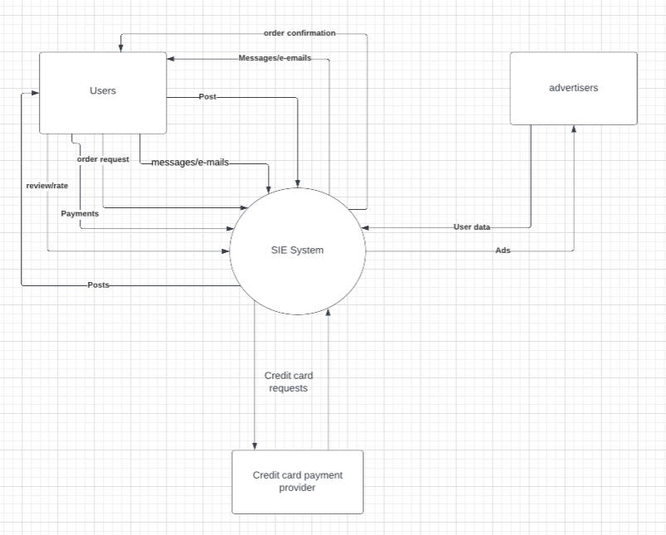

# 5. Assumptions and Constraints

## 5.1 ASSUMPTIONS

The following is a list of assumptions:

* Assume all users are over the age 18 and university students
* Ignore any tax issues
* Payment can only be done through registered credit card
* Internet Connection: All the students in the university have access to a reliable internet connection
* Ignore Post project maintenance issues
* Ignore any contract negotiation and legal concerns.
* Assume all user know to download and install application or browse web-application
* Assuming that users will not post any fake job posting, tutoring services and merchandise

## 5.2 CONSTRAINTS

The following is a list of constraints:

* Our developers are not trained in Android programming
* Project schedule too short and must be completed no longer than 3 months
* Must use MySQL database
* Website/application not available offline
* Users needs to be student or enrolled in university to register
* Resources are limited

# 6. Project Tasks, Schedule and Cost

|  |  |  |  |  |
| --- | --- | --- | --- | --- |
| **Level No.** | **Tasks** | **No. of**  **units** | **$Monthly** | **Total**  **cost** |
| 1.0 | Project Management |  |  |  |
| 1.1 | Project Manager | 1 | $10000 | $30000 |
| 1.2 | Resources | 5 | $5000 | $75000 |
| 2.0 | Health insurance (50% extra surge) |  |  | $52500 |
| 3.0 | **Hardware** |  | **Cost** |  |
| 3.1 | Servers | 4 | $2200 | $8800 |
| 3.2 | Monitors and Desktops | 6 | $2000 | $12000 |
| 3.3 | Other Devices | 6 | $500 | $3000 |
| 4.0 | **Software** |  |  |  |
| 4.1 | Operating systems License | 6 | $60 | $360 |
| 4.2 | Database License | 1 | $250 | $250 |
| 4.3 | Other Software/Security licenses | 6 | $100 | $3600 |
| 5.0 | **Testing** | 6 | $100 | $600 |
| 6.0 | **Training** |  |  |  |
| 6.1 | Creating backups | 6 |  | $9000 |
| 6.2 | Learning and Features development | 6 |  | $70,000 |
| 7.0 | **Deployment** |  |  |  |
| 8.0 | Recreation and Team outings | 6 |  | $15000 |
| 9.0 | Project Reserve for Emergencies | 1 |  | $120,000 |
|  | Total Project Estimate |  |  | $400,110 |

The project cost estimate without any profit is $400,110. The profit margin is 100%.

The project cost estimate along with the profit margin is $800,220.

# 7. Conclusion and Recommendations

Thus, In order to ensure that the most crucial project features are completed and made available to the customer, the main features of the project were planned and implemented in phases. Within a 3-month period, it is ensured that every module has been implemented with excellent quality and few bugs or errors. If we have an extra two to one months, we can complete the remaining modules with extra features.

Although there were some potential risks like,

• Project Deadlines

• Funding the Project

• Promotion time

• Quality of the product

• Market Release of the Product

My advice to the board of directors would be to increase the number of resources assigned to the project as this would help to complete it well ahead of schedule and may also ensure that more extra features are added to the application, increasing the company's profit margin projections. This will be very helpful in financing the company's further projects. Additionally, this would open the door for other prospective clients in the dealership industry to invest in the program. Our market share would rise if we had a large consumer base. This would be a step toward achieving our corporate goal of dominating the market.

# Appendices

* https://www.indeed.com/career-advice/career-development/project-management-metrics
* https://www.spheregen.com/cost-of-software-development/
* <https://www.guru99.com/what-is-sdlc-or-waterfall-model.html>
* <https://www.simplilearn.com/feasibility-study-article>
* https://www.lucidchart.com

Hardware

* ThinkSystem SR655 Rack Server 1P/2U Optimized for VDI and SDI
* ThinkCentre M70q Tiny Gen 2
* Samsung C34H890WGN - CH89 Series - LED monitor